HSE Monthly Report – May 2026
Weyland Energy – all sites
Hannah Weber · 09 June 2026 · HSE-RPT-2026-05

1. Headlines
Highest number of safety observations so far (348). One restricted work case on MV Sea Atlas (knee injury on the gangway). Kestrel Ridge internal audit completed with 2 minor findings.
Indicator | May | YTD 2026 | 2025
Hours worked | 263,000 | 884,000 | 1,452,000
Lost time injuries | 0 | 1 | 2
Recordable injuries | 1 | 4 | 6
First aid cases | 4 | 22 | –
Near misses | 38 | 159 | 307
Safety observations | 355 | – | –
LTIFR rolling 12 months | 1.13 | – | 1.38
TRIR rolling 12 months | 4.53 | – | 4.13

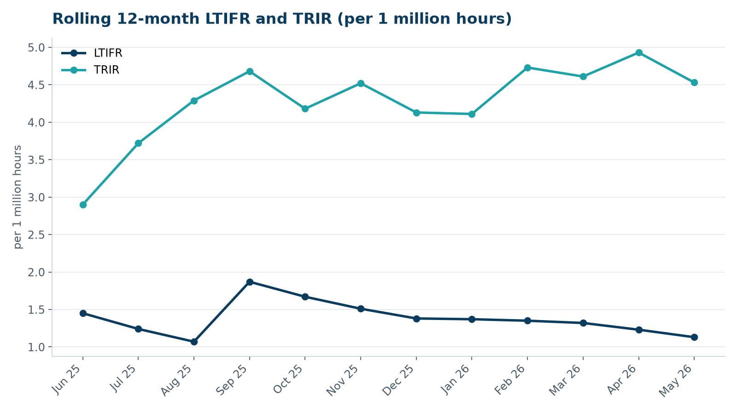

2. Hours by group
Group | Hours | Share
Weyland employees | 63,000 | 24 %
O&M contractors (operating assets) | 38,000 | 14 %
Harrow Bay contractors | 162,000 | 62 %

3. Leading indicators
- Toolbox talks delivered: 139
- Management safety walks: 10 (target 12)
- Inspections of lifting equipment: 42
- Open corrective actions older than 30 days: 11

4. Focus for next month
Fatigue management for offshore crews during long weather windows.
Hannah Weber, HSE Manager

